**FORM 2**

THE PATENTS ACT, 1970

(39 of 1970)

AND

THE PATENTS RULES, 2003

**COMPLETE SPECIFICATION**

(See Section 10; rule 13)

TITLE OF THE INVENTION

**Real-Time Weapon Detection System Using Deep Learning and Computer Vision**

**Field and Background of this Invention**

The present invention related to the weapon detection. This also includes the sensor technologies,

Artificial intelligence and machine learning for the recognizing weapons in the public area, like airport, school, political office, etc.

Now a days, usage of weapon was more and making much nonsense in public was increased. So, to reduce the violence we are manually using this method to detect the weapons in the restricted area.  
However, current AI-based systems is accepting many challenges like, high false positive rates, inability to function in crowded environments, and difficulty identification between actual weapons and toy weapons that can looks so similar.

**Summary of this Invention**

The invention shows a real-time weapon detection system that works using weapons analysis over continuous camera feeds. The solution gives a mix of computer vision and deep learning for recognition of weapons in the restricted area. It processes AI to detect the weapons over the range of some applications:

Stage 1: **Frame Acquisition and Preprocessing**

The invention shows a real-time weapon detection system that works using weapons analysis over continuous camera feeds. The solution gives a mix of computer vision and deep learning for recognition of weapons in the restricted area. It processes AI to detect the weapons over the range of some applications:

This is the process of taking input data (images or video frames) from a source such as:

CCTV cameras, Live video feeds (e.g., IP cameras), Video files, etc.

Preprocessing enhances the input frame to improve detection performance. The basic preprocessing steps include:

a. Resize Frames: Normalize the input size for your detection model (e.g., 224x224, 640x480).

b. Convert to Grayscale: Reduces the load and may increase detection if colour is not crucial.

c. Noise Reduction: Remove noise with Gaussian Blur or Median Blur.

Stage 2: **Classification Model**

Creating a significant model for weapon detection that involves building a deep learning system also can identify images or video frames into elated like "weapon" and "no weapon", or multiple classes like "knife", "gun", etc.

Here’s an enormous of the full pipeline:

1.Data preparation

2.Data preprocessing

3.Model Architecture

4.Training

5.Evaluation

6.inference on videos

Each pipeline can derive the brief information of the weapon detection steps.

You can use a pretrained CNN or build your own model.

Each image should be labelled appropriately.

**Integration and Output**

To integrate a significant model for weapon detection and to produce outputs in real-time or batch, you basically need to:

1.Load your trained model

2.Capture video frames or read images

3.Preprocess the frames

4.Make predictions

5.Display or act on the results

This can assume:

You trained a model for identifying frames as "weapon" or "no weapon".

Firstly, we have to load the model and define labels then take the pictures to predict frame by frame, later save the generated outputs.

**Key Benefits of the Invention**

* **Enhanced Public Safety**:

Weapon detection systems can recognize weapons, such as firearms or knives, before they are carrying outside. This helps to reduce the violence incidents and reduces the

harmfulness at the places like airports, schools, political offices, etc.

* **Proactive Threat Prevention:**

Before the attacks happen, weapon detection systems enable proactive intervention. By identifying potential threats before they happening, these systems allow security system to take awareness action.

* **Improved Efficiency and Speed**:

The automatic weapon detection can identify threats without the need for manual searches, speeding up the security process can take less wait times for individuals entering restricted areas.

* **Minimized Human Error**:

Manual weapon searches can be liable to monitoring or human error, but automated detection systems reduce the danger of missing hidden weapons. This provides a higher level of accuracy in identifying threats.

**Detailed Description of this Invention**

**1. Overview**

The invention of weapon detection systems is a technically designed to recognize and get rid the unwanted weapons carrying or use of weapons in restricted areas. These systems are majorly based on the collaboration of sensors, machine learning algorithms, imaging technology, and communication networks. The aim is to identify hidden weapons, such as firearms, knives, or volatile and in real time, allowing timely actions and improving overall security.

**2. Core Components of the Invention**

Detection Technologies:

It can detect the secret items in bags, covers, etc.

Common in luggage scanning at platforms and employees screening.

it uses Thermal and Infrared Cameras

Identify hidden weapons based on some type of signatures.

Can detect previously handled firearms or devices that emit heat.

Artificial Intelligence and Machine Learning

**3. Operation and Functionality**

Basically, the weapon detection can operate on following:

First is Data Collection

Sensors or cameras collect real-time data from the surroundings.

Next is Preprocessing and Feature Extraction

Then Raw data is filtered and similar features are extracted.

Then go with the Threat Analysis Using some AI Models

Security systems are like door bells; alarms may be automatically activated.

Real-time location data and video can be produced to share with first responders.

**4. Types of Deployment**

Fixed Systems: Installed in main areas such as entrances of buildings, airports, or schools.

Mobile Units: Attached on vehicles or compact platforms for use at non-permanent events or checkpoints.

Wearable Detectors: Used by security workers for distinct scanning in crowds.

Drone-Based Detection: Assigned in the large areas or hazard areas to identify for weapons using cameras and sensors**.**

**5. Advanced Features**

Facial Recognition Integration: Links individuals with threat history to detected weapons.

Behavioural Analysis: Observers body language or step to identify doubtable behavior alongside weapon detection.

Cloud Connectivity: Allow centralized data storage, remote monitoring, and AI model updates.

Privacy Safeguards: Also includes data masking and data safety measures to maintain moral use.

**6. Applications**

Airports, train stations, such as public transports

Government and military facilities

Schools and universities

Stadiums, concerts, and large events

Shopping malls and complexes

Border checkpoints

**Claim**

**1. Surveillance and Security Cameras:**

Where used: Airports, schools, malls, train stations.

Reason: Autonomous guns, knives, or other weaponsdetection in real-time using AI.

Pros: Alerts the security before an attack is happening.

**2. AI-Powered Smart Alarms:**

Where used: Banks, stores, public buildings.

Reason: If a weapon is detected by the cameras or sensors, the system can ring an alarm.

pros: quick response to threats.

**3. Police Body Cams and Dash Cameras:**

Where used: Done by police officers.

Reason: AI able to scan video footage to identify weapons.

pros: Helps officers to get the evidence quickly.

**4.Common Technologies Used:**

CCTV + AI: Cameras use artificial intelligence to detect weapons in real-time.

Thermal Scanners: Detect metal objects like guns using heat signatures.

Millimetre-Wave Scanners: Often used at airports to see through clothing without privacy attack.

### ****ABSTRACT****

The increase in the public safety risks has required the advancement of smart technologies that are able to detect possible threats instantly in real-world. This project presents a weapon detection system designed to automatically identify firearms and different kinds of weapons employing modern computer vision and AI-based learning algorithms. Utilizing convolutional neural networks (CNNs) and object detection models like YOLO (You Only Look Once) or Faster R-CNN, the system is trained on a varied dataset of images and video frames featuring different types of weapons across diverse environments. The developed model exhibits high precision and minimal delay, rendering it well-suited for real-time monitoring in public areas, educational institutions, airports, and other high-security locations. Future works are also may include in this for improving and spreading the detection under using some techniques and also expanding the dataset for broader applicability.  
This weapon detection can significantly minimize the negatives while existing the security measures.

***Keywords****—* Weapon Detection, Gun Detection, Knife Detection, Firearm Detection, Concealed Weapon Detection, Threat Detection, Object Detection, Image Classification, Video Surveillance, Real-time Detection.

***List of Figures:***

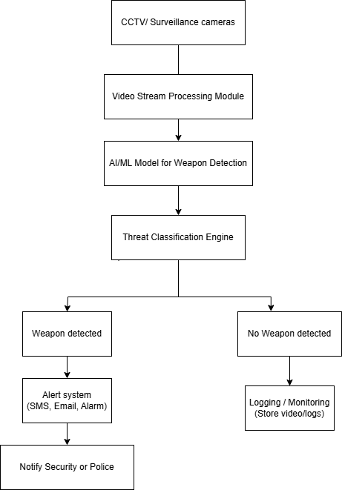

***Figure: 1 Proposed Architecture for weapon detection***

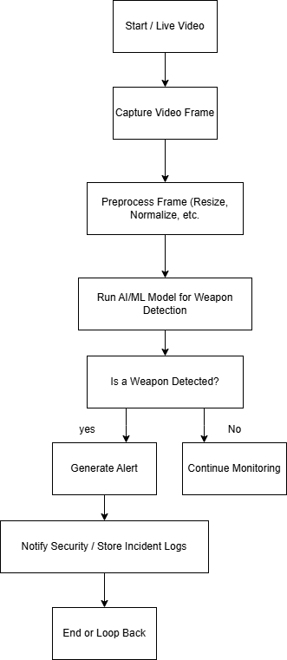

***Figure: 2 Flow Chart***

**Figure 1: Detected: Pistol and knife**

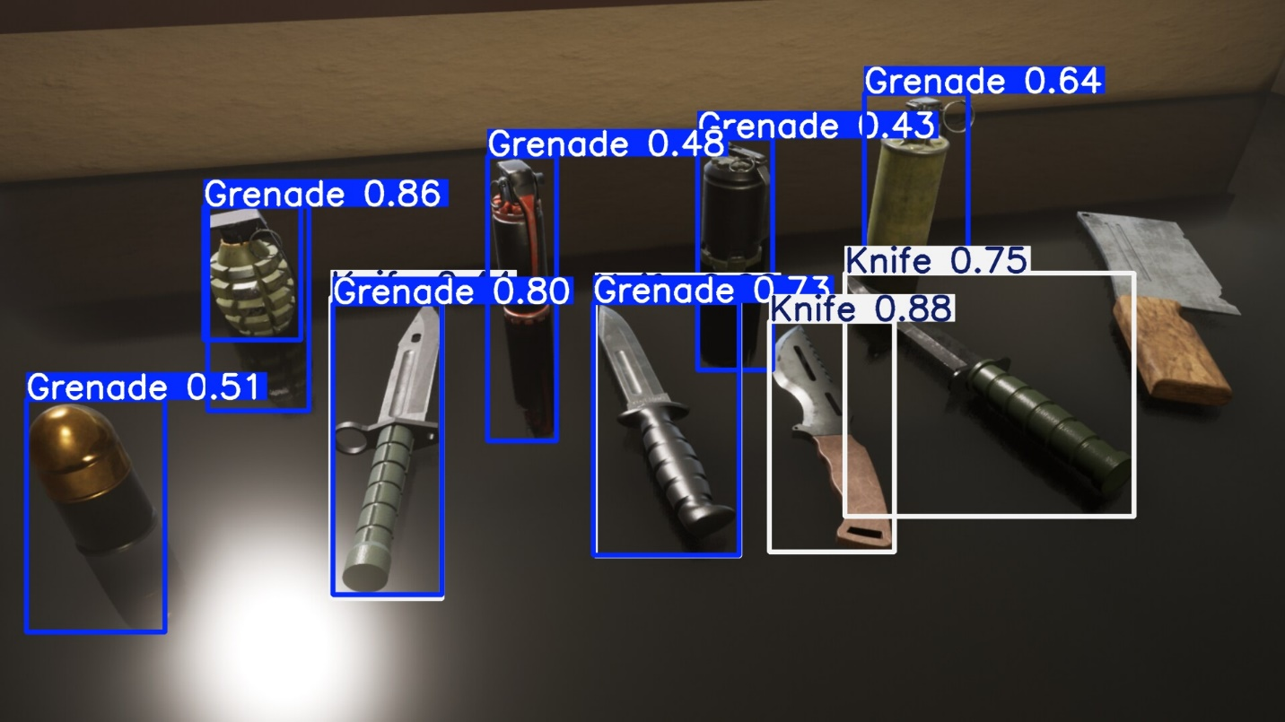

**Figure 2: Detected: Weapons**

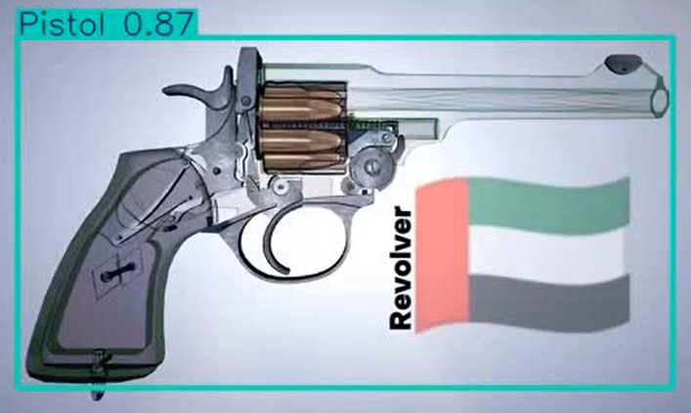

**Figure 3: Pistol Detected**

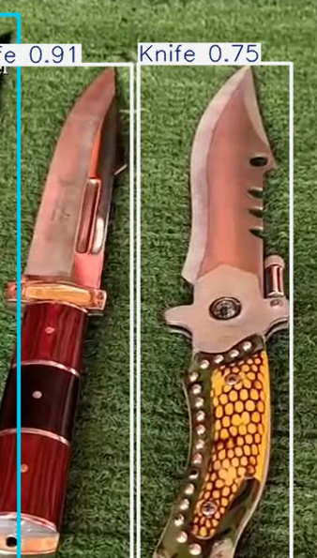

**Figure 4: Knifes detected**

***List Of Tables:***

|  |  |  |  |  |
| --- | --- | --- | --- | --- |
| CLASS | ACCURACY | PRECISION | RECALL | F1 SCORE |
| GRENADE | 84.1 | 0.870 | 0.860 | 0.865 |
| GUN | 84.2 | 0.996 | 0.762 | 0.864 |
| KNIFE | 84.3 | 0.984 | 0.774 | 0.867 |
| PISTOL | 84.4 | 0.746 | 0.884 | 0.809 |
| BACKGROUND | 0.00 | 0.00 | 0.00 | 0.00 |

Table 1: Comparative performance of weapon detection models based on backend architecture and optimizer